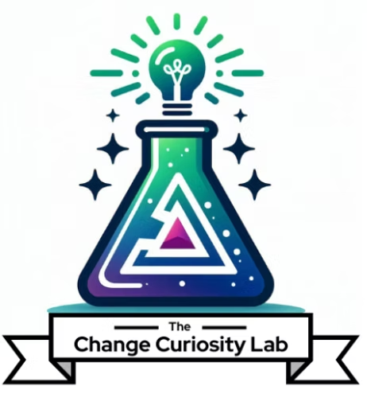
The Lab Apprenticeship
Instructional Methods
Provider | Format | Duration | CM Instructional Hours | Language
The Change Curiosity Lab, LLC | Self-Paced / Blended | 8 weeks | 9 hours + 8 hours self-study/application | English
This document describes the instructional methods and adult-education principles used to deliver The Lab Apprenticeship. The program is a practicum: participants learn by doing, applying each concept to real change work under expert coaching, with a required human-review beat that teaches them to judge and improve AI output rather than accept it.

1. Adult-Learning Foundation
Instruction is grounded in established principles of adult learning (andragogy). Across the program, instruction is:
- Relevant and applied – every concept is practiced on the participant’s own real or a hypothetical change initiative.
- Self-directed – on-demand micro-learning lets participants control their pace and revisit content as needed.
- Experiential – participants build real, usable change deliverables rather than completing worksheets.
- Guided – live coaching and directed feedback support skill development at each step.

2. The Module Learning Cycle
Each module follows a consistent instructional sequence that moves participants from concept to demonstrated skill:
- Learn – three roughly 10-minute on-demand videos each week introduce the module concepts.
- Watch – a live concept introduction followed by a “Watch Me Work” build of a real AI-augmented change deliverable, on screen from scratch.
- Try (guided) – participants build alongside within the same session, with real-time coaching.
- Build – participants complete the module artifact between sessions, applying the concept to their own context.
- Feedback – expert, personalized feedback within 48 hours on each submitted deliverable.
- Present and defend – a final portfolio review where participants present and defend their complete body of work.

3. Instructional Methods Used
The Apprenticeship uses a variety of teaching methods appropriate to a blended, skills-based practicum:
Method | How it is applied in the Apprenticeship
Direct instruction / presentation | Concept introductions in each live session and three roughly 10-minute on-demand videos per week.
Live demonstration | “Watch Me Work” sessions where a real AI-augmented change deliverable is built from scratch on screen.
Guided practice | In-session “You Try,” where participants build alongside with directed, real-time coaching.
Skill-building exercises | A module artifact built between sessions, applying the concept to the participant’s own context.
Critical thinking & decision-making | Evaluating, verifying and validating AI-generated outputs before use, through the required human-review beat.
Structured feedback | Personalized written feedback within 48 hours on each deliverable, plus live coaching feedback in session.
Self-directed study | On-demand videos, workbooks, templates and prompt frameworks accessible throughout the program.
Observation & discussion | Watching real builds followed by cohort discussion and question-and-answer.
Peer learning | A small cohort with shared sessions and a midpoint retrospective.

4. Guided Practice and Feedback
Skill development is monitored and supported through directed feedback at multiple points: real-time coaching during the guided “You Try,” personalized written feedback within 48 hours on each submitted deliverable, a cohort retrospective at the program midpoint, and a final portfolio review and defense. Feedback addresses both the change management quality of the work and the participant’s judgment in applying AI.

5. Accommodating Different Learners
Participants arrive with different experience levels and learning preferences. The program accommodates this by:
- Delivering content in multiple modalities (on-demand video, live demonstration, hands-on build, written feedback and discussion), so different learning styles are supported.
- Letting participants apply every concept to their own real work context, meeting them where they are.
- Providing coaching and feedback calibrated to each participant’s experience level within a small cohort.
- Recording all live sessions so participants can revisit content and learn at a flexible pace.

6. Feedback and Assessment of Understanding
Participant understanding is assessed through the work they produce. Each module deliverable is reviewed against quality criteria, and completion requires successful presentation and defense of a capstone portfolio evaluated with a competency rubric. This rubric-scored capstone serves as the course knowledge assessment. Periodic feedback throughout the program confirms progress before the final assessment.

7. Materials and Access
Participants have ready access to all course materials throughout the program: on-demand instructional videos, module workbooks, artifact templates and prompt frameworks, plus recordings of every live session, delivered through a private members area.

The Change Curiosity Lab, LLC · The Lab Apprenticeship · Instructional Methods

