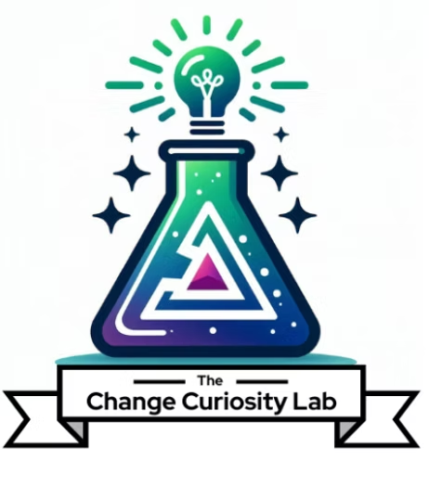
The Lab Apprenticeship
Learning Objectives
Provider | Format | Duration | CM Instructional Hours | Language
The Change Curiosity Lab, LLC | Self-Paced / Blended | 8 weeks | 9 hours + 8 hours self-study/application | English
The learning objectives below define what participants can do on completion, at the program level and within each module, mapped to the ACMP Standard for Change Management. Objectives are written as observable, demonstrable competencies at the application and creation level.

Program Learning Outcomes
By the end of the Apprenticeship, participants can:
- Apply AI tools to core change management deliverables while maintaining human judgment, accuracy and quality control.
- Produce a portfolio of change management work products that align to the ACMP Standard for Change Management.
- Evaluate AI-generated outputs for accuracy, bias and organizational fit before applying them to live change work.
- Construct and defend a personal, reusable AI-augmentation approach for their own change management practice.

Module Learning Objectives

Module 1 – The AI-Augmented Change Mindset
On completion of this module, participants can:
- Build a structured prompt framework (WHO / WHAT / WHY / HOW / WHAT NOT) tailored to their change context.
- Articulate the difference between using AI and using it well.
- Identify appropriate and inappropriate AI use cases in their practice.
ACMP Standard alignment: Foundational, supports responsible application across all knowledge domains.

Module 2 – Stakeholder and Readiness Intelligence
On completion of this module, participants can:
- Produce a stakeholder analysis and readiness assessment for a change initiative using AI augmentation.
- Interpret and validate AI-generated readiness intelligence, applying human judgment to an organization’s readiness, ability and capacity to change.
- Translate impact and readiness data into a decision-useful dashboard.
ACMP Standard alignment: Evaluating Change Impact and Organizational Readiness (anchor domain).

Module 3 – AI-Powered Communications and Change Artifacts
On completion of this module, participants can:
- Develop an audience-tailored change communication package using AI.
- Adapt messaging to distinct stakeholder audiences based on impact and readiness inputs.
- Apply human review to preserve accuracy, tone and organizational voice.
ACMP Standard alignment: Developing / Executing Change Management Plans (secondary domain).

Module 4 – Present, Defend and Sustain
On completion of this module, participants can:
- Assemble and present a portfolio of AI-augmented change management deliverables.
- Defend their AI-augmentation choices, including value, limitations and safeguards.
- Design a sustainable plan for embedding AI into their ongoing change management practice.
ACMP Standard alignment: Consolidation and reinforcement; touches Closing the Change Effort.

The Change Curiosity Lab, LLC · The Lab Apprenticeship · Learning Objectives

