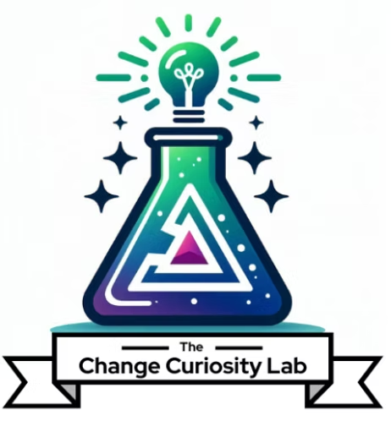
The Lab Apprenticeship
Assessment Criteria
Provider | Format | Duration | CM Instructional Hours | Language
The Change Curiosity Lab, LLC | Self-Paced / Blended | 8 weeks | 9 hours + 8 hours self-study/application | English
This document describes how participant learning is assessed in The Lab Apprenticeship, through ongoing formative feedback and a summative, rubric-scored capstone. The rubric-scored capstone serves as the course knowledge assessment.

1. Assessment Overview
Assessment operates in two layers. Formative assessment runs throughout the program: participants receive coaching and personalized feedback on each deliverable, so they can improve before the final review. Summative assessment is the capstone: participants present and defend a portfolio of their four module deliverables plus an “AI in my Change Management practice” one-pager, scored against a competency rubric. The rubric-scored capstone is the course knowledge assessment.

2. Formative Assessment (ongoing)
Throughout the program, participant progress is monitored and supported through:
- Personalized written feedback on each submitted module deliverable, within 48 hours.
- Real-time coaching and directed feedback during the guided “You Try” in each live session.
- A cohort retrospective at the program midpoint to surface and address gaps early.

3. Completion Criteria
To complete the Apprenticeship and earn the certificate and Credly badge, a participant must:
- Submit all four module deliverables (prompt starter kit, readiness and stakeholder intelligence, change communication package, and the practice one-pager).
- Present and defend the capstone portfolio in the final session.
- Achieve Proficient (3) or above on every criterion of the capstone rubric in Section 5. Where a criterion is scored Developing (2) or below, the participant receives feedback and revises and resubmits until Proficient is reached.

4. Records
Attendance, submitted deliverables and assessment results are maintained and are accessible to participants on request. Records are retained for a minimum of three years.

5. Summative Assessment: Capstone Portfolio Rubric
The capstone portfolio and live defense are scored against the six criteria below. Proficient (3), the shaded column, is the completion standard for every criterion.
Criterion | Not Yet (1) | Developing (2) | Proficient (3) | Exemplary (4)
Change management rigor (ACMP Standard alignment) | Work does not reflect sound change management practice. | CM approach present but gaps in rigor or Standard alignment. | Sound CM practice, clearly aligned to the relevant knowledge domains. | Sophisticated, well-justified practice, tightly aligned to the Standard.
Using AI well (effective application) | AI use is absent, superficial or misapplied. | AI used but with limited effect or inconsistent technique. | AI applied effectively to produce quality deliverables. | AI applied skillfully and creatively, clearly amplifying the work.
Human judgment & output verification | AI output accepted without review or correction. | Some review, but gaps in accuracy, bias or fit checks. | Consistent review; outputs verified for accuracy, bias and fit. | Rigorous, critical verification with clear improvements to output.
Deliverable quality & completeness | Deliverables missing or unusable. | Deliverables present but incomplete or rough. | All four deliverables complete, professional and usable. | Portfolio is polished, cohesive and client-ready.
Presentation & defense | Unable to explain or justify choices. | Explains work but limited justification of AI choices. | Defends AI choices, including limitations and safeguards. | Compelling, confident defense with strong critical insight.
Sustainable practice integration (one-pager) | No realistic plan to embed AI in practice. | General intent but a vague or impractical plan. | Clear, realistic plan to embed AI responsibly in practice. | Specific, actionable plan with safeguards and next steps.
Scoring and threshold. Each criterion is scored on a four-point scale (1 Not Yet, 2 Developing, 3 Proficient, 4 Exemplary). Completion requires Proficient (3) or above on all six criteria. A criterion scored Developing (2) or below returns to the participant with feedback for revision and resubmission until Proficient is reached, so completion reflects demonstrated competency rather than an average score.

The Change Curiosity Lab, LLC · The Lab Apprenticeship · Assessment Criteria

