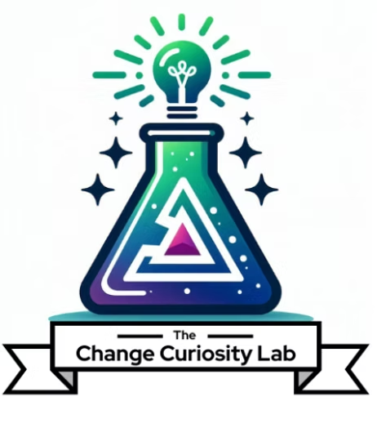
The Lab Apprenticeship
Course Evaluation Process
Provider | Format | Duration | CM Instructional Hours | Language
The Change Curiosity Lab, LLC | Self-Paced / Blended | 8 weeks | 9 hours + 8 hours self-study/application | English
This document describes how the effectiveness of The Lab Apprenticeship is evaluated and how improvements are made based on the results. It is distinct from participant assessment: it measures and improves the course itself.

1. Purpose
The Apprenticeship operates a continuous evaluate-and-improve cycle. Evidence is gathered from participants, from assessment results and from the facilitator throughout every cohort, then reviewed to strengthen the course before the next cohort runs. The goal is a program that stays relevant, effective and aligned to the ACMP Standard for Change Management as practice and tools evolve.

2. What the Course Evaluates
Evaluation focuses on whether the course is relevant, well delivered and genuinely building capability:
Evaluation focus | What it tells us | Primary source
Content relevance | Whether material matches practitioner needs | Pulse survey, end-of-program evaluation
Facilitation quality | Effectiveness of live sessions and coaching | Pulse survey, end-of-program evaluation
Applicability | Whether participants can use it in real work | End-of-program evaluation, deliverable quality
Capability gain | Growth in participant confidence and skill | Pre/post self-assessment
Learning outcomes met | Whether objectives are achieved | Capstone rubric results
Experience & pacing | Workload, platform and flow of the program | Pulse survey, midpoint retrospective

3. How Feedback Is Collected
Instrument | Timing | Focus
Module pulse survey | End of each module | Clarity, relevance, applicability, pacing
Midpoint retrospective (live) | Program midpoint | Real-time course correction
End-of-program evaluation | Final week | Overall content, facilitation, applicability, capability gain
Capstone rubric results | Final assessment | Which outcomes are met and where participants struggle
Facilitator debrief | After each cohort | Instructor reflection on what worked and what did not
Employer / manager feedback (optional) | Post-program | Applied impact of the work back on the job

4. The Improvement Cycle
After each cohort, the evidence is turned into concrete changes through a documented cycle:
- Collect. Gather all evaluation signals across the cohort (surveys, retrospective, rubric results, facilitator debrief).
- Review. Assess results against the learning outcomes and the participant experience.
- Prioritize. Identify the highest-impact changes, distinguishing content, materials, pacing and facilitation.
- Revise. Update module content, on-demand videos, templates or delivery accordingly.
- Re-launch. Apply the changes before the next cohort and record what changed and why.

5. Evaluation Cadence
When | What happens
End of each module | Pulse survey reviewed; minor adjustments made mid-cohort where needed
Program midpoint | Live retrospective; in-flight course corrections for the current cohort
End of cohort | Full review of all signals; improvement decisions documented
Between cohorts | Revisions applied and recorded before the next launch

6. Transparency and Records
Evaluation results and the resulting changes are documented and retained, and participants are told how their feedback is used. This keeps the course operating in an open and transparent manner and ensures each cohort benefits from the experience of those before it.

The Change Curiosity Lab, LLC · The Lab Apprenticeship · Course Evaluation Process

